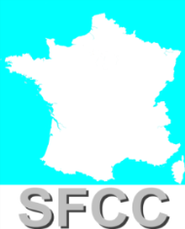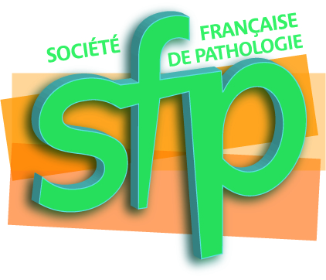 | 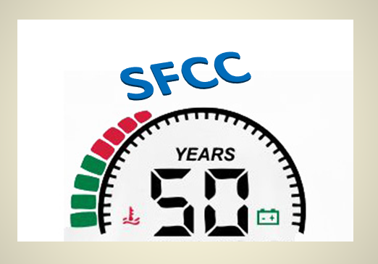 | 

Welcome to the 50th anniversary of

the French Society of Clinical Cytology

Looking at the Past and into the Future

of Cytopathology

22th November 2017

Convention Centre “Palais des Congrès”, Paris, France

Dear Colleagues,
On behalf of the organizing committee, I am delighted to invite you to the 50th anniversary of the French Society of Clinical Cytology meeting, to be held on 22 November 2017, at the Palais des Congrès in Paris, France. The scientific meeting, hosted by the French Society of Pathology (SFP), will, we hope, attract a wide audience whatever their background or interest in the field of cytology, from Europe and beyond. It will be an opportunity to learn new developments, share best practices, refresh our skills but also to reunite with old friends.
The scientific program (limited to the afternoon), will cover different aspects of cytology, with sessions covering morphology, best practice, guidelines, and new techniques.
The meeting will take place in the “Palais des Congrès”, a strategic location in Paris and one of the world‘s most significant Congress Center with a wide range of nearby hotel accommodation.

A gala evening will be held, with in beginning a comedy “l’Avare”(“ The Miser”) from Moliere, played at the Ranelagh Theater. Molière whose real name was Jean Baptiste Poquelin composed 12 of the most satirical and durable comedies of all time, including "L’Avare”, (French). It is a five-act comedy first performed in 1668, in the theatre of the Palais-Royal in Paris. The miser of the title is called Harpagon, a name adapted from the Latin harpago, meaning a hook or grappling iron. He is obsessed with the wealth he has amassed and is always ready to save expenses. You will attend a modern, unconventional version of this play performed by the “Grenier de Babouchka” troop. As the play starts, a state-of-the-art English subtitles or “surtitles” will be projected just above the stage; it's as easy as reading subtitles for a movie. A glossy printed program will serve as a souvenir! A cocktail party will then be served in the foyer and galleries of the theater.

Paris is well known for fashion, culture, food and entertainment. It benefits from a very convenient public transportation system which includes the metro and the bus, but do not hesitate to rent the Velib bikes to discover the whole city, enjoy the banks of the Seine and all the Parisian jewels. Also take time to have a drink in the many Parisian cafés. Victor Hugo said that “Respirer Paris, cela conserve l’âme”, that you can translate as “Breathing Paris preserves your soul”, and Hemingway wrote “A moveable feast”, translated in French as “Paris est une fête”. As all the Parisians who love their beautiful city, we are convinced that this meeting will not only be scientifically exciting but also that you will fall in love with Paris.

We look forward to welcoming you to Paris for this exciting and festive 50th anniversary of SFCC !

Dr Beatrix Cochand-Priollet
President of 50th anniversary of the French Society of Clinical Cytology (SFCC) Organizing Committee

Organisation & Scientific Commitee
SFCC board (Website: www.francesfcc.org)
Béatrix Cochand-Priollet, President, Hôpital Cochin, PARIS
Monique FABRE : Past-President, Hôpital Necker Enfants Malades, PARIS
Christine BERGERON : Vice Président, Laboratoire Cerba, CERGY PONTOISE
Monique COURTADE-SAÏDI: General Secretary, Institut Universitaire du Cancer - Oncopole, TOULOUSE
Eric PIATON: Secretary, Centre de Pathologie EST, BRON
Bénédicte ROYER: Chair Treasurer, Centre de Pathologie et d’Imagerie, PARIS
Hervé DEBAQUE: Treasurer, SCP des Drs Bloget et Declerck, AVON

Preliminary Programme

2.30-2.35: Introduction.
J. Smith (UK), Mr Loyal
2.35-2.50: My history and the history of cytopathology.
V. Schneider (Germany)
2.50-3.05: Quality control in an organized screening programme.
L. Di Bonito (Italy)
3.05-3.20: Cervical cancer screening: What will be the role of the cytotechnician if primary HPV screening is introduced and how will the colposcopist cope with ’screening by colposcopy’?
A. Herbert (UK)
3.20-3.35: the interpretation of HPV-positive borderline cytologies: new challenges in gynecologic cytology
G. Negri (Italy)
3.35-3.50: The Paris system 2015 for reporting urinary cytology: a two-year assessment. E. Wojcik (USA)

3.50-4.15: Coffee-break

4.15-4.30: The Milan system 2016 and molecular advances in the cytological diagnosis of salivary gland tumors
DE Rossi (Italy)
4.30-4.45: Guidelines for cytopathological diagnosis of malignant mesothelioma: the 2015 European diagnostic protocol
P. Firat (Turkey)
4.45-5.00: Challenges and opportunities of lymph node FNA

P. Zeppa (Italy)

5.00 5.15: Thyroid cytology : can it be replaced by molecular testing

D. Poller (UK)

5.15-5.30: Cytopathology in the future: new worlds to conquer

F. Schmitt (Portugal)

5.30-5.45: Top Quiz for residents with awards ceremony

J. Smith (UK), Mr Loyal and Members of SFCC committee

Social Events: Gala Evening (Nov. 22, 2017, (8h15– 11h00 pm), Play and Diner cocktail, Ranelagh Theater

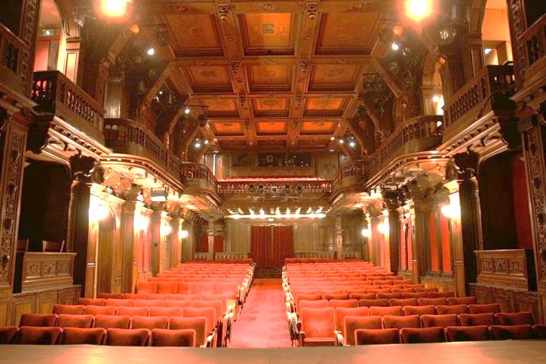

The theater will welcome you from 8:15 pm. It is located 2 steps from the Eiffel Tower and the Maison Radio France:Theater of Ranelagh, 5, rue Vignes, 75016 Paris. The play will start at 8:45 pm (be on time), « smart casual ».

Located outside the city limits at the time, a theatre was built in Château de Boulainvilliers belonging to Alexandre Le Riche de La Pouplinière, a great patron of the arts. Intellectuals and artists such as Voltaire and Rameau visited the theatre. After the Revolution left the property partially devastated, a famous automobile manufacturer and music enthusiast, Louis Mors, acquired the land and had the original theatre reconstructed on the site of the original La Pouplinière Music Hall in 1894. The rich and warm carved oak panelling that adorns the venue in a Neo-Renaissance style gave the room exceptional acoustics, and remains to be a cinema of art and essay today. Here in this cozy theatre. ​(5 rue Vignes 75016)
Step into the grand auditorium of the Theater of Ranelagh, and prepare to be wowed by the ornate carved oak panelling adorning the orchestra and balconies, as well as the intricately decorated ceiling. Looking around you it’s not hard to believe that this building is listed as one of Paris’ 'historical monuments'…

Comedy
‘Molière in ’The Miser’’ takes us through the last 15 years of the protagonist’s chaotic and difficult life, introducing us to the women he loved, the friends he valued and, of course, the enemies he loathed. Also showing us various notable encounters such as that with King Louis XIV, the one-man show takes us right up to the end, examining the strange circumstances surrounding Molière’s death…

Important Dates
Registration Opens: June 2017

Scientific congress

Early Bird Carrefour Pathologie 2017 Registration Fees Deadline: By 10 September 2017
Opening of “Carrefour Pathologie 2017 congress ” (French congress): 20 November 2017
Opening of SFCC 50th Years scientific meeting (English session): 22 November 2017

Gala evening

Deadline of Gala evening (play and cocktail) registration fees: 14 July 2017

The Carrefour Pathologie 2017 registration fees are:

A special rate for the day of November 22nd is exceptionally offered for this 50th Birthday of SFCC by the French Society of Pathology to foreign participants (pathologists, technologists and cytotechnologists) who only like to attend this session in English, the rest of the congress being in French (See congress website: (http://www.carrefour-pathologie.org). This rate is not offered to the French pathologists. This special rate is only available for registration before September 10, 2017 and includes attendance, English program for the SFCC event, refreshment breaks.

Registration and payment received By 10 Sept., 2017 After 10 Sept., 2017

1-Day (22 November, 2017) 100€ 440€

Foreign participants wishing to attend the 4 days of the Carrefour Pathologie Congress can register themselves as the French participants on the congress website (http://www.carrefour-pathologie.org), benefiting if they are members of the French Society of Pathology (SFP) of a special rate.

Registration and payment received By 10 Sept., 2017 After 10 Sept., 2017

4-Day Francophone Pathologists, non-member of SFP 350€ 440€

4-Day Francophone Pathologists, member of SFP 170€ 220€

To register, please use the following link : http://hopscotch.key4events.com/?e=87

Upon receipt of the registration and the corresponding payment, the congress office will send a confirmation to the participant which also serves as an invoice. Please present this confirmation of registration at the congress counter when picking up your congress material.

Carrefour Pathologie 2017 web site

http://www.carrefour-pathologie.org

Contact
​Organisation: info@carrefour-pathologie.org
Registration: congres@hopscotchcongres.com +33 1 70 94 65 35

The gala evening registration fees are:
50 euros per place, only before July 14 (including play and dinner party)
Specify at the time of the registration request,
Last name:
First Name:
Mobile phone number:
E-mail address:
Number of places required: □ 1 □ 2 □ ....

Upon receipt of the gala evening registration and the corresponding payment, the SFCC office (sfcc.secretariat@gmail.com ) will send a confirmation to the participant which also serves as an invoice. Please present this confirmation of registration at the Ranelagh Theater

A wire transfer must be made to the SFCC bank whose bank account (IBAN) is as follows:

Account owner: SOCIETE FRANCAISE DE CYTOLOGIE CLINIQUE, Boite 34, 8 rue de Rochechouart – 75009 Paris

Name of the bank: LA BANQUE POSTALE

Adress of the bank: LYON CENTRE FINANCIER, 166 AVENUE JEAN JAURES 69900 LYON CEDEX 20 – FRANCE

BIC: PSSTFRPPLYO

IBAN: FR10 2004 1010 0701 9355 3G03 887
All payments must be made in EUR.
Thank you for putting the name of the person (or persons) who register on the back of the check

Location of the Carrefour Pathologie 2017 meeting

Palais des congrès de Paris

2 Place de la Porte de Maillot

75017 Paris

France

How to get to the venue

Directions from and to the congress venue
When you come by public transport to the congress venue, please go to the following stops:
Subway station Porte Maillot
RER Porte Maillot
Bus 43, 73, 82, 244, PC1, PC3
Travelling from Roissy-Charles de Gaulle Airport to Palais des Congrès de Paris
By train
- RER B, stop at “Chatelet Les Halles”
- then take RER A to “Charles de Gaulle/Etoile”
- then line 1 of the metro to “Porte Maillot/Palais des Congrès” (approximate travel time: 75 minutes)
By Air France or ADP shuttle bus
- take line 2 (buses go directly to “Porte Maillot/Palais des Congrès” or to the “Opéra” in the city centre)
- departure every 20 minutes from 06:00 to 22:00 costing €17 (approximate travel time: 1 hour).
By taxi
- approximate travel time to central Paris is 30/45 minutes depending on traffic. However, this can be as quick as 20 minutes after 21:00 from CDG to congress centre.
Travelling from Orly Airport to Palais des Congrès de Paris
By train
- high speed shuttle (Orlyval) to “Antony”
- RER B, stop at “Chatelet Les Halles”
- then take RER A to “Charles de Gaulle/Etoile”
- then line 1 of the metro to “Porte Maillot/Palais des Congrès” (approximate travel time: 60 minutes)
By the “Cars Air France”
- go to “Terminus Etoile”
- then line 1 of the metro to “Porte Maillot/Palais des Congrès”
- departure every 30 minutes from 06:00 to 23:00 (approximate travel time: 40-60 minutes)
By taxi
- approximate travel time to central Paris is 40-60 minutes depending on traffic.

Location of Gala Evening in Ranelagh Theater

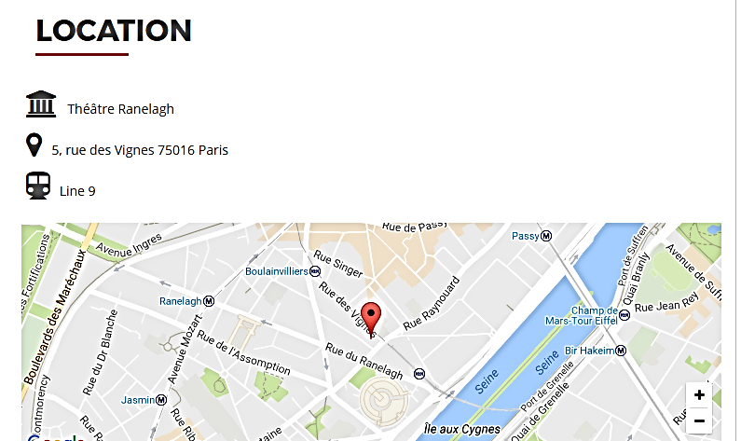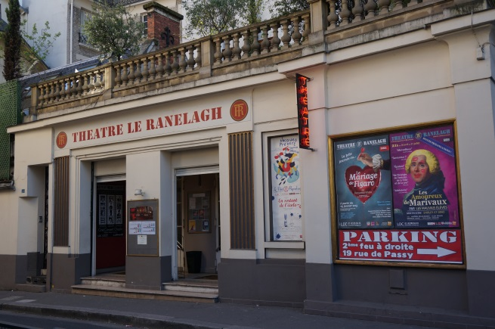

Accommodation

For reservation:

Contact: a.t.i booking by HOPSCOTCH CONGRÈS

http://www.carrefour-pathologie.org/heacutebergement.html

Email to: carrefourpatho2017@atibooking.com

Tel.: 33140546400



