46th Professor Janez Plečnik Memorial Meeting
with International Symposium

ADVANCES IN ORAL DISEASES

December 3-4, 2015
Faculty of Medicine, University of Ljubljana
Korytkova 2, 1000 Ljubljana Slovenia

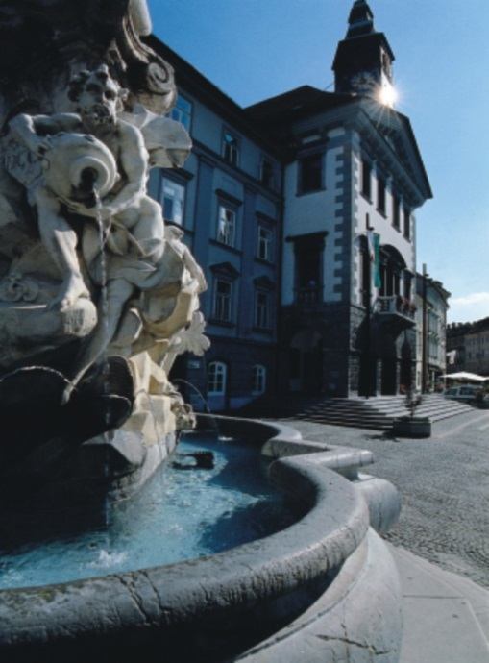
Dear Colleagues,
The traditional Memorial meeting, the main scientific event organized by the Faculty of Medicine, University of Ljubljana each year since 1971, is dedicated to the pathologist and anatomist Professor Janez Plečnik, one of the founders of the Faculty of Medicine, University of Ljubljana. The moto of this event is focused on promoting his idea about necessity of collaboration between basic and clinical sciences in medicine.
This year's Memorial meeting with an international scientific symposium will be dedicated to Advances in Oral Diseases and will take place on 3rd and 4th December, 2015. Several internationally recognized and Slovenian pathologists and clinicians will present the most important topics of oral diseases.
You are kindly invited to attend the meeting, and also to participate in this event actively with posters. The instructions for posters with the deadline are included below.
Venue: Faculty of Medicine, University of Ljubljana, Korytkova 2, 1000 Ljubljana, Slovenia

Official Languages: Slovene and English; all lectures will be in English
Registration: No registration fee; participants can register by e-mail (jera.jeruc@mf.uni-lj.si) or an hour before the opening of the meeting in the enterance hall of the Faculty of Medicine, University of Ljubljana, Korytkova 2, 1000 Ljubljana, Slovenia

We look forward to welcoming you to Ljubljana in December.

Assist. Professor Jože Pižem, MD, PhD Professor Nina Gale, MD, PhD

President of the Organizing Committee President of the Scientific Committee

PROGRAMME

Thursday, December 3, 2015
8.00-9.00 Registration – No registration fee
9.00-9.30 Opening Ceremony/Welcome Address

- Inflammatory, infectious and immune-mediated diseases
10.00-10.20 Matija Gorjanc: Periimplantitis – important clinical problem for dental surgeons (Ljubljana, Slovenia)
10.20-10.40 Nataša Ihan-Hren: Intraoral actinomycosis (Ljubljana, Slovenia)
10.40-11.10 Justin A. Bishop: HIV infection in oropharyngeal region (Baltimore, USA)
11.10- 11.50 Boštjan Luzar, Alenka Vizjak: Autoimmune diseases of oral cavity - important topic for clinicians (Ljubljana, Slovenia)
11.50-12.00 Discussion

12.00-13.00 Lunch

- Precursor lesions and malignant epithelial tumors
13.00-13.30 Justin A. Bishop: Overview of HPV infection in head and neck (Baltimore, USA)
13.30- 14.00 Nina Gale: Oral precursor lesions – gallimaufry of classifications (Ljubljana, Slovenia)
14.00-14.30 Nina Zidar: Subtypes of oral squamous cell carcinoma (Ljubljana, Slovenia)
14.30-15.00 Maria Pia Foschini: Molecular diagnostic changes in squamous cell carcinoma of the oral cavity (Bologna, Italy)
      - Discussion

      - Coffee Break

- Diagnostic procedures and management of oral cancer
15.30-15.50 Margareta Fležar-Strojan: Cytology of oral and oropharyngeal region: possibilities and perspectives (Ljubljana, Slovenia)
15.50-16.10 Robert Šifrer: The role of Narrow-Band Imaging in diagnostics and therapy of oral and oropharyngeal cancer (Ljubljana, Slovenia)
16.10-16.30 Vojko Didanovič: Surgical treatment of oral cancer and oropharyngeal cancer (Ljubljana, Slovenia)
16.30- 16.50 Primož Strojan: Non-surgical treatment of oral and oropharyngeal cancer (Ljubljana, Slovenia)
16.50-17.00 Discussion

19.00 Concert of Medical Doctors, Slovenian Philharmonic

Friday December 4, 2015
- Tooth and jaw development, developmental defects, odontogenic cysts and tumors
9.00- 9.20 Erika Cvetko: Important aspects of tooth and jaw development (Ljubljana, Slovenia)
9.20-9.50 Pieter Slootweg: The most frequent developmental defects of the oral and maxillofacial region (Nijmegen, The Netherlands)
9.50-10.20 Pieter Slootweg: Odontogenic cysts (Nijmegen, The Netherlands)
10.20-10.50 Edward Odell: Odontogenic tumors (London, UK)
10.50-11.00 Discussion

11.00-11.30 Coffee Break

- Fibro-osseous lesions, benign and malignant bone tumors of the jaws
11.30-12.00 Edward Odell: Fibro-osseous lesions of the jaws (London, UK)
12.00-12.30 Eugenio Maiorano: Benign bone tumors of the jaws (Bari, Italy)
12.30- 13.00 Eugenio Maiorano: Malignant bone tumors of the jaws (Bari, Italy)
13.00-13.10 Discussion

13.10-14.30 Lunch
VI. Poster Session – Guided poster presentations (during lunch time)

VII. Salivary gland and soft tissue tumors
14.30-15.00 Alena Skalova: Current news of salivary gland tumors (Plzen, Czech Republic)
15.00-15.20 Jože Pižem: Soft tissue tumors of the oral cavity (Ljubljana, Slovenia)
15.20-15.50 Metka Volavšek: Lymphoproliferative lesions of the salivary glands (Ljubljana, Slovenia)
15.50-16.00 Discussion

VIII. Slide seminar
16.00-17.30 Chairpersons: Jelena Sopta (Belgrade, Serbia), Spomenka Manojlović (Zagreb, Croatia): Differential diagnostic problems of oral lesions

17.30 Closing remarks Nina Gale (Ljubljana, Slovenia)

46th PROFESSOR JANEZ PLEČNIK MEMORIAL MEETING with International
Symposium ADVANCES IN ORAL DISEASES
December 3 - 4, 2015
Faculty of Medicine University of Ljubljana, Korytkova 2, Ljubljana, Slovenija

POSTER PREPARATION
Width 100 cm, height 130 cm
Poster Presentation will be held at the Main Hall of the Faculty of Medicine, Korytkova 2.
Please display posters on Thursday, December 3 before 9.am and collect them on Friday, December 4 before 5pm. Guided poster presentations will be on December 3 and/or 4 during the lunch time.
If you wish your presentation to be published on a CD, please send it by October 30, 2015 to: prof. dr. Nina Gale, dr. med.
Institute of Pathology, Faculty of Medicine, University of Ljubljana
Korytkova 2, 1000 Ljubljana, Slovenia
nina.gale@mf.uni-lj.si

Instructions for posters to be published on a CD
The text should not exceed one A4 page. Please use font Times New Roman 12 pts.
In addition to the text, colour microphotographs are welcome.
References should be numbered consecutively, by Arabic numerals, as they appear in the text (in brackets). List all authors when 6 or less; when 7 or more, list only the first 3 and add et al.
See example below:
Dockwell H, Greenspan JS. Histochemical identification of T-cells in oral lichen planus. Oral Surg 1979; 42: 227
The text should include: title, authors' names, affiliations and address of the corresponding author.
If this is a case report, please prepare your text as follows:
- Clinical history
- Macroscopic features
- Microscopic features
- Diagnosis
- Comments
- References (up to 5)

If this is a research paper, please prepare it as a structured abstract with the following subheadings:
- Introduction
- Material and methods
- Results and discussion
- References (up to 5)

