Upcoming seminar of Pituitary center of excellence:
TTF1 positive posterior pituitary tumors

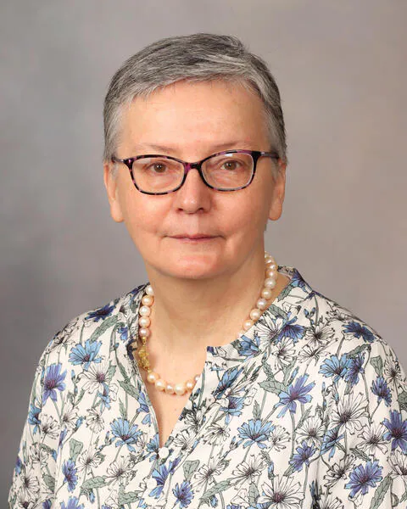

Caterina Giannini, MD, PhD
Full professor of Anatomic Pathology
Department of Laboratory Medicine & Pathology
Mayo Clinic, Rochester (MN) USA

Date:
14.10.2025, 14:30
Conference room, Department of Neurosurgery and Neurooncology
Military Universtity Hospital, Prague
CH1, 1st floor

